I. True or False?

T | F | 1. | Myoglobin is characterized by a Hill coefficient that is a negative number.
T | F | 2. | Single amino acid mutations in proteins in humans are always detrimental eventually resulting in disease.
T | F | 3. | DEAE-cellulose resin binds proteins that possess a net negative charge.
T | F | 4. | Peptide bonds are usually trans.
T | F | 5. | Enzymes can alter the reaction conditions to allow non-spontaneous reactions to occur.
T | F | 6. | NAD⁺ can be an important reductant in redox reactions.
T | F | 7. | A catalyst acts by lowering yhe activation barrier for the reaction being catalyzed.
T | F | 8 | One turnover by succinate dehydrogenase yields one equivalent of FADH₂.
T | F | 9 | Michaelis-Mentin kinetics assumes that the Michaelis complex is consistently increasing over the course of the enzyme reaction.
T | F | 10. | Trypsin specificity is conferred by a deep hydrophobic (non-polar) pocket.

II. Calculations
The molecular weight of SDS is 223 g/mole. Calculate how much SDS you would need to make 100 ml of the following solutions:

11. 200 mM SDS

A. 4.5
B. 0.0045 g SDS
C. 4.5 kg SDS
D. 4.5 mg SDS
E. 4.5 g SDS

12. 20 % SDS

A. 446 g SDS
B. 446 mg SDS
C. 20 g SDS
D. 20 mg SDS
E. 2.0 g SDS

13. 20 mg/ml SDS

A. 2.0 g SDS
B. 2.0 mg SDS
C. 4.5 mg SDS
D. 0.45 mg SDS
E. 4.5 g SDS

III. Matching

Below are five graphs in which the solid line indicates oxygen binding to a pure homogenous hemoglobin solution. Choose which graph (“A – E”) best represents the following scenarios? Note: “A – E” may be used more than once.

________ 14. The dashed line representing an increase in the pH of the hemoglobin solution.

________ 15. The dashed line representing the oxygen binding curve of myoglobin.

IV. Other multiple-choice questions (# 16 – 20). Choose the most correct answer.
During your Senior Honor’s thesis work, you isolated five new proteins and determined their molecular weights and pI’s. Your thesis advisor gave you the opportunity to name them since you discovered them. You think hard about what you want to name them and decide you will name them after your favorite mentors and teachers. You prepare a table in alphabetical order of each protein’s name to organize your new proteins and their characteristics as follow:

Protein Name | Molecular Weight (kDa) | pI
Protein “Briggs” | 100 | 5.0
Protein “Fox” | 250 | 10.0
Protein “Legge” | 80 | 6.8
Protein “Tu” | 15 | 4.5
Protein “Yeo” | 45 | 9.5

16. Your thesis advisor asks you to go back and do another purification to isolate more of your proteins for characterization. You decide to try and change the conditions to optimize purification. The first column that you decide to try is a DEAE-cellulose column which is equilibrated in a buffer at pH 7.0. Which of the proteins listed below will NOT bind to the column?
- Fox
- Legge
- Tu
- Both “A.” and “B.”
- All of the above

17. In order to elute the bound proteins from the DEAE cellulose column in #11, you can use which of the following method (s)?

A. Increase the salt concentration.
B. Decrease the pH of the buffer on the column.
C. Increase the pH of the buffer on the column.
D. Either “A.” or “B.”
E. Either “A.” or “C.”

18. Which of your proteins would migrate the furthest or the longest distance on an SDS-PAGE gel?

A. Briggs
B. Fox
C. Legge
D. Tu
E. Yeo

19. In a gel filtration experiment, the order that your proteins would elute would most likely be as follows:
A. Briggs, Fox, Legge, Tu, Yeo
B. Fox, Briggs, Legge, Tu, Yeo
C. Tu, Yeo, Legge, Briggs, Fox
D. Fox, Briggs, Legge, Yeo, Tu
E. Briggs, Fox, Yeo, Tu, Legge
20. Which of the following molecule is considered a denaturant?

A. Urea
B. Ampholytes
C. Lysozyme
D. Ammonium sulfate
E. NADH

21. A reaction with ΔH = 11 kJ/mol and ΔS =40 J/K·mol, at 27°C, is:

A. spontaneous
B. non-spontaneous
C. at equilibrium
D. impossible to determine reactivity
E. none of the above

22. What is the [OH–] in a 0.05 M HCl solution?

A. 5 × 10^{–12} M
B. 1 × 10^{–13} M
C. 2 × 10^{–13} M
D. 5 × 10^{–13} M
E. 2 × 10^{–14} M

23. Which of the following amino acids has a sulfur atom in its side chain?

A. Asn
B. Ser
C. Cys
D. Phe
E. None of the above

24. How many possible sequences are there for a tetrapeptide using the 20 amino acids?

A. 80
B. 256
C. 2,560
D. 25,600
E. 160,000

25. Trypsin digestion of a peptide yields the fragments (H, MNK, IMR, and LMR). Cyanogen bromide treatment yields (RH, RM, NKIM, and LM). What is the sequence of the intact peptide?

A. NKIMRHLMRM
B. LMRHNKIMRM
C. LMRMNKIMRH
D. LMRIMRMNKH
E. NKIMLMRHRM
Shown below is a titration curve for glutamic acid. Examine the structures of the glutamic acid species (A – E) below. Choose the correct answer from “A – E” (questions #26-28).
Note: “EtOH – E” may be used more than once.

26. What is the structure of the species that predominates at the labeled point “ 1 ”? ________

27. What is the structure of the species that predominates at the labeled point “ 5 ”? ________

28. Which of the structures cannot exist as shown at any pH in aqueous solution? _________

A. B. C. D. E.

29. Which one of these characteristics is not true for the α-helix?
A. There are 3.6 amino acids per turn.
B. There is a requirement for glycine every third amino acid residue.
C. A hydrogen bond forms between the carbonyl oxygen of the nth amino acid residue and the —NH group of the (n + 4)th amino acid residue.
D. Proline is typically not found in the α helix.
E. It is right-handed.
30. Which amino acid can stabilize protein structures by forming covalent cross-links between polypeptide chains?

A. Met
B. Ser
C. Glu
D. Gly
E. Cys

31. The value of n in the Hill equation for hemoglobin is about ______as great as the value for myoglobin.

A. half
B. twice
C. three times
D. five times
E. ten times

32. Conformtion(s) that has (have) both a favorable hydrogen bonding pattern and φ and ψ values that fall within the Ramachandran conformational regions is (are) _______.

- α-helix
- Collagen helix
- β-sheet.
- None of the above
- All of the above

33. The φ and ψ angles for the α-helix in an area on a Ramachandran diagram corresponding to:

A. φ is negative and ψ is negative
B. φ is positive and ψ is positive
C. φ and ψ are both 0°
D. φ is negative and ψ is positive
E. φ is positive and ψ is negative

34. Which of the following statement(s) concerning the Bohr effect is (are) true?

A. Lowering the pH shifts the O₂ dissociation curve of hemoglobin to the right.
B. The affinity of hemoglobin for O₂ is diminished by high concentrations of CO₂.
C. In the lung, the presence of higher concentration of O₂ promotes the release of CO₂ and H⁺.
D. “A.” or “B.” only
E. “A.” or “B.”, and “C.”

35. Based on the table below, treatment of the polypeptide (D-M-L-F-M-R-A-Y-G-N) with chymotrypsin will not generate:

A. M-R-A-Y
B. D-M-L-F
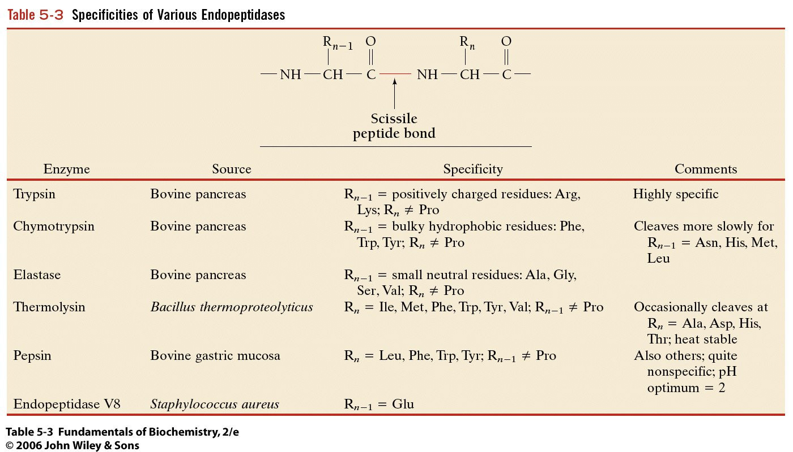
C. Y-G-N
D. G-N
E. All of the above

36. Serine proteases catalyze peptide cleavage via a covalent intermediate linked to which of the
following amino acids?

A. serine D. lysine
B. histidine E. tyrosine
C. aspartic acid

37. Which of these statements is true about the coordinate regulation of phosphofructokinase (PFK) and fructose –1,6-bisphosphatase (FBPase)?

A. AMP stimulates PFK and inhibits FBPase.
B. Fructose2,6 bisphosphate inhibits PFK and activates FBPase.
C. Acetyl-CoA inhibits PFK and activates FBPase.`
D. Citrate stimulates PFK and inhibits FBPase.
E. NADPH activates PFK and inhibits FBPase.

38. The pathway/s that use citric acid cycle intermediates include which of the following:

A. Amino Acid Biosynthesis D. Both A and C
B. Fatty Acid Biosynthesis E. All of the above.
C. Glucose Biosynthesis
39. Acetyl CoA

A. is a high energy compound
B. is a carrier of acetyl or acyl groups
C. can be used to drive endergonic processes
D. is both A. and B.
E. is A. B. and C.

40. Which of the following co-factors are required for catalysis by hexokinase?

A. NAD+ D. Mg²⁺
B. FAD+ E. Mn²⁺
C. lipoic acid

41. Which of the following is not a good electrophile?

A. protons D. carbonyl carbons
B. cationic imines E. metal ions
C. methyl groups

42. Which of the following properties is NOT a characteristic of enzymes?

A. Enzymes theoretically stabilize the transition state of the reaction they catalyze.
B. Enzymes alter the equilibrium distribution of the substrate(s) and product(s) of the reaction they catalyze.
C. Enzymes reduce the activation energy of the reaction they catalyze.
D. Enzymes employ a wide variety of catalytic strategies.
E. Enzymes vary widely in their catalytic efficiencies.

43. Michaelis and Menten assumed that the overall enzyme-catalyzed reaction could be written as
$E+S\underset{k−1}{\overset{k1}{↔}}\text{ES}\overset{k2}{→}E+P$
Using this reaction, what expression best describes the rate of formation of the ES complex?

A. k1([ET] –[ES])[S] D. k-1[ES]
B. k-1[ES] + k2[ES] E. k1([ET]-[ES])
C. k2[ES]

44. If pyruvate is labeled with [¹⁴C] at the carbon of the carboxylic acid, how many equivalents of GTP will be produced before all of the radioactivity is released as ¹⁴CO₂?

A. 0 equivalents of GTP D. 4 equivalents of GTP
B.   equivalents of GTP E. none of the above
C. 2 equivalents of GTP

45. If oxaloacetate is labeled with [¹⁴C] at the C-1 carbon, how many rounds of the Citric acid
cycle are required before any [¹⁴CO₂] is released?
A. 0 cycles D. 3 cycles
B. 1 cycle E. [¹⁴CO₂] is never released.
C. 2 cycles

The figure below right shows the dependence of an enzyme’s rate, v (in μM/min), as a function of substrate concentration, S (in mM). Also shown is the dependence of the rate on the presence of an inhibitor, present at a concentration of 2 mM. Use this information to answer questions 46 and 47.
46. The V_{max} of the enzyme is approximately:

A. 0.25 μM/min D. 2 μM/min
B. 0.5 μM/min E. 4 μM/min
C. 1.0 μM/min

47. The K_{M} of the enzyme is approximately:

A. 0.25 mM D. 2 mM
B. 0.5 mM E. 4 mM
C. 1.0 mM

48. Which of the carbon(s) of glucose must be labeled with [¹⁴C] for the end products of alcoholic fermentation to be unlabeled ethanol and [¹⁴CO₂]?

A. 4-[¹⁴C]-glucose D. 1-[¹⁴C]-glucose
B. 3-[¹⁴C]-glucose E. Both A. and B.
C. 2-[¹⁴C]-glucose

49. 2-phosphoglycate inhibits TIM. In an anaerobic system that is metabolizing glucose as a substrate, which of the following compounds would you expect to increase in concentration rapidly following the addition of 2-phosphoglycate?

A. dihydroxyacetone phosphate D. glyceraldehyde-3-phosphate
B. 1, 3-bisphosphoglycerate E. 2-phosphoglycerate
C. phosphoenolpyruvate

50. The structure of a ¹⁴C labeled Pyruvate molecule is given below. Which of the following options “A-E” correctly describe the origin of the label from Glucose?

¹⁴CH₃
⏐ .
C=O
⏐
C=O
⏐
O⁻

A. pyruvate was originally Carbons 3 or 4 in glucose.
B. pyruvate was originally Carbons 2 or 5 in glucose.
C. pyruvate was originally Carbons 1 or 6 in glucose
D. the label came from Carbon 2 in glucose
E. the label came from Carbon 1 in glucose

Bonus Question
51. When studying the effects of pH on the V_{max} of an enzyme catalyzed reaction, a researcher obtained a graph where there was no activity of the enzyme above pH 8.0; however, the enzyme was fully active at pH 6.0. What reasonable hypothesis can you conclude about this enzyme?

A. The protonation of a Lys group was important for the catalysis of the reaction.
B. The protonation of a His group was important for the catalysis of the reaction.
C. The deprotonation of a His group was important for the catalysis of the reaction.
D. The deprotonation of a Asp or Glu group was important for the catalysis of the reaction.
E. The protonation of a Asp or Glu group was important for the catalysis of the reaction.

